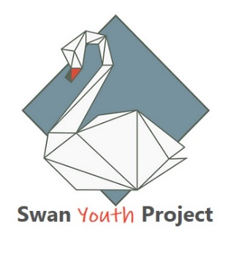

Referral Form to Swan Youth Project
Young Persons Details
Name
Date of Birth |  | Contact Phone Number
Address and postcode
School year |  |  | Nationality
Parent/carer name and relationship to YP |  |  | Parent/carer Phone Number

Additional information about the YP
Medical conditions
Additional Needs
Main reasons for referral, please be as specific and detailed as possible
Type of support being requested (1:1/ small group/ other)

❑ Suicide Ideation
❑ Self-harm
❑ Suspected Mental
Health
❑Anger management
❑Bullying
❑Social Functioning
❑Relationship difficulty
❑Grief & Loss
❑Low self-esteem
❑Sexuality/Gender Identity
❑Housing/
Homelessness issues
❑Education
❑Legal/non-criminal
❑Connection to the
community
❑Domestic violence
❑Sexual assault
❑Child protection

Person making the referral
Relationship to young person
E-mail
Phone

Information we collect about the young person and any activities they take part in at this venue will be stored securely and only used for running activities. Anonymised information will be shared with funders to help the service to continue. Personal information will not be shared without consent to third parties unless required by law or for safeguarding reasons. By signing this form, you acknowledge that Swan Youth Project will store your data in compliance with the GDPR. ☐ Yes ☐ No Tick Yes to confirm your acknowledgement, if no,we will not be able to continue with the referral.

I have discussed this referral with the young person and they have given consent Yes ❑ No❑ N/A ❑

I discussed this referral with the young person’s parent/guardian Yes ❑ No❑ N/A ❑

Worker Signature: ___________________________

Parent signature:____________________________

Date:_____________________________

Information Sharing Consent
Name of young person
Name of parent/carer

I hereby give my permission for The Swan Project to share personal information about the above young person with the named school and vice versa in connection with academic achievement and social/emotional needs or concerns. I understand that The Swan Project may hold information gathered and as such my rights under the Data Protection Act will not be affected.

Statement of Consent:
- I understand that personal information is held about me or the young person in my care.
- I have had the opportunity to discuss the implications of sharing or not sharing information about me or the young person in my care.
- I agree that personal information about me or the young person in my care may be shared and gathered from the following agencies:
  - NHS and other Health Services, including my GP practice
  - Early Intervention Service including the police
  - Adult Services
  - Mental Health Services
  - Education Support Services
  - Social Care
  - Voluntary Sector Organisations
  - Housing Providers

Are there any agencies you do not want us to share or gather additional information with? Please list them here:
____________________________________________________________________________________________________________________________

I agree to my information being shared and gathered between services
Yes No

Parent/carer name:

Signature:
Your consent to share personal information is entirely voluntary and you may withdraw your consent at any time. Should you have any questions about this process, or wish to withdraw your consent please contact Anna Foster on 01366 386259

Please return completed forms to:

E-mail address: anna@theswanproject.org Phone: 01366 386259

